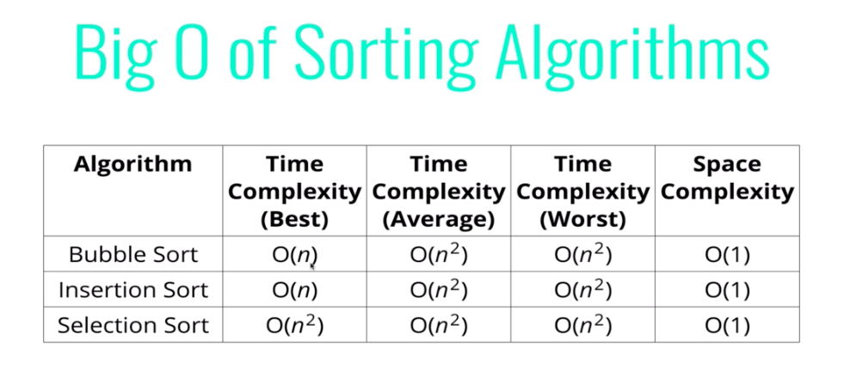

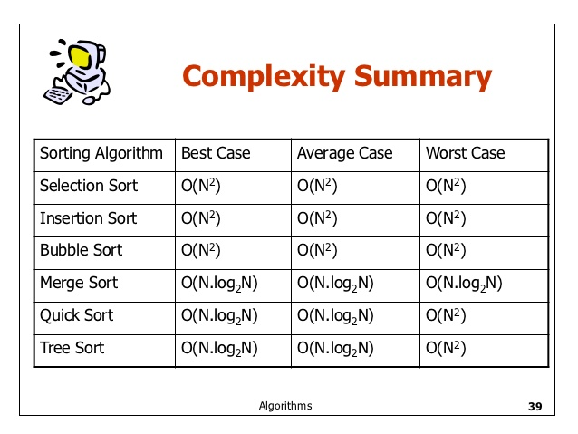

Read the following for more insight on fastest algorithm.

https://www.quora.com/What-is-the-fastest-sorting-algorithm

**Quick sort** – pivot element and put smaller elements than pivot element into left and larger elements into right then take the quick sort of left and right again and merge them

**Merge sort –** you divide the array into halves as much as possible until the size of the array becomes 1. If the size of the array is 1 then you can return the array. Otherwise you can divide the array again into halves and call their merge sort function again separately and merge them. Merging is done as smallest elements goes to left and largest elements go to right.

**Bubble sort** – take first two elements and compare them put the larger element right and smaller element left. Repeat it until the array is finished. After first iteration the largest element is at the right most position. In the next iteration we only need to run the bubble up to the n-1. After running this for n-1 times we can take the sorted array.

We can optimize this algorithm as follows. Inside a one iteration if theres no swap we can conclude that the array is sorted.

**Insertion sort** –

**Selection sort** – taking the minimum index and put it in front. First iterate starts from first element lets call it key. And then we can compare rest of the right side elements

23,45,34,1,2

23

1,2 45,34

1 45

2 34

Lets 7 elements in an array.

Divide this into two array

4 – 3